1 - Sketch the system of inequalities.

x + 2y ≤ 32
x ≥ 0, y ≥ 0



2 - Sketch the system of inequalities.
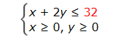


3 – Sketch the system of inequalities.
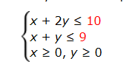
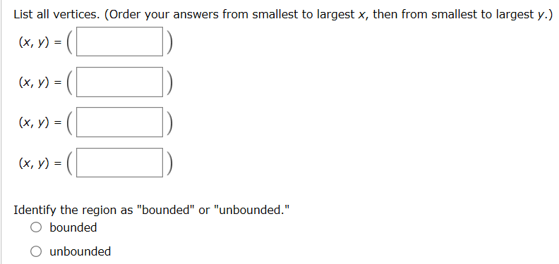

4 - Sketch the system of inequalities. List all vertices and identify the region as "bounded" or "unbounded."
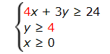


5 - Formulate the situation as a system of inequalities. (Let x represent the number of goats the farmer can raise and y represent the number of llamas.)
A rancher raises goats and llamas on his 400-acre ranch. Each goat needs 2 acres of land and requires $90 of veterinary care per year, while each llama needs 5 acres of land and requires $72 of veterinary care per year. If the rancher can afford no more than $11,880 for veterinary care this year, how many of each animal can he raise?

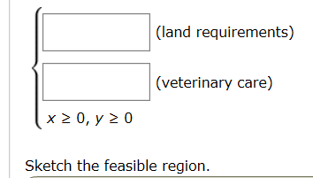


6 - Use the region below to find the maximum value. (If such a value does not exist, enter DNE.)
Maximum of P = 5x + 3y
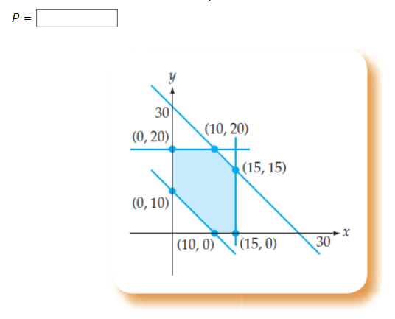
7 - Use the region below to find the minimum value. (If such a value does not exist, enter DNE.)
Minimum of C = 7x + y

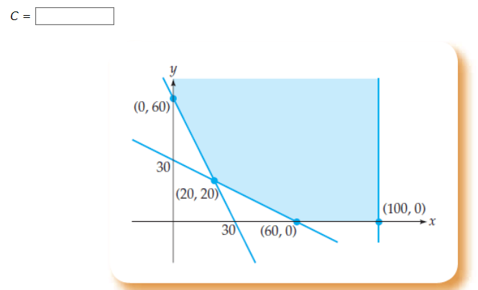

8 - Solve the linear programming problem by sketching the region and labeling the vertices, deciding whether a solution exists, and then finding it if it does exist. (If an answer does not exist, enter DNE.)
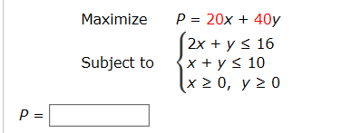

9 - Solve the linear programming problem by sketching the region and labeling the vertices, deciding whether a solution exists, and then finding it if it does exist. (If an answer does not exist, enter DNE.)
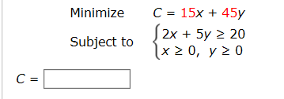

10 - Solve the linear programming problem by sketching the region and labeling the vertices, deciding whether a solution exists, and then finding it if it does exist. (If an answer does not exist, enter DNE.)
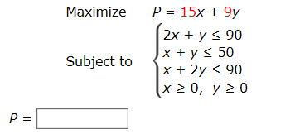

11 - Formulate the situation as a linear programming problem by identifying the variables, the objective function, and the constraints. Be sure to state clearly the meaning of each variable. Determine whether a solution exists, and if it does, find it. State your final answer in terms of the original question.
A rancher raises goats and llamas on his 400-acre ranch. Each goat needs 2 acres of land and requires $100 of veterinary care per year, and each llama needs 5 acres of land and requires $80 of veterinary care per year. The rancher can afford no more than $13,200 for veterinary care this year. If the expected profit is $48 for each goat and $72 for each llama, how many of each animal should he raise to obtain the greatest possible profit?

